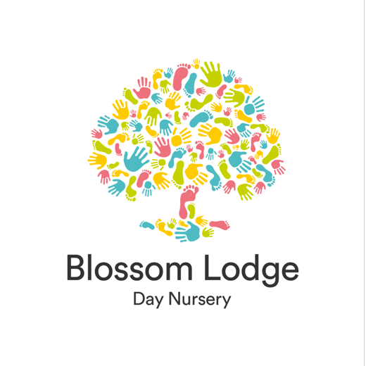

Funding Guide

Funding at Blossom Lodge Day Nursery

This guide is here to help, explaining who’s eligible and how to apply, with clear information every step of the way.

Available Funded Childcare
15 Hours – 9 months to 2 years old

Many parents will be able to apply for 30 hours funding for children 9 months and older.
Parents working at least the equivalent of 16 hours a week at the national living wage, with individual incomes of less than £100,000 annually can apply. If one partner doesn’t work or if one partner earns over £100,000, eligibility may not apply.
Visit www.beststartinlife.gov.uk to apply. If your application is successful, you will be sent a funding code which needs to be provided to your chosen nursery.
Alternatively, if you receive benefits or if your child is in receipt of Disability Living Allowance or has an education, health and care (EHC) plan, you may qualify for 15 hours funding for your 2-year-old child.

15 Hours – 3 and 4 year-olds
All parents of 3- and 4-year-old children are entitled to the 15 hours funding. This can be discussed with your chosen nursery. There is no need to apply for this funding, the nursery will help you complete the parent declaration for the nursery to claim the funding for the relevant term.

30 Hours – 3 and 4 year-olds
In addition to the universally accessible 15 hours of funded childcare for parents of 3- and 4-year-olds, you might qualify for an extra 15 hours.
Applicants must be employed and working a minimum of the equivalent of 16 hours per week at either the national living wage or minimum wage, and their individual incomes should be below £100,000 annually. It is important to note that if one partner is not employed or if their earning exceed £100,000, eligibility may not apply.

Funding FAQ’s
Understanding the childcare funding can be difficult, and we understand the importance of having clear and concise information available.
We hope our funding guide can address the common questions on funded childcare.

What age groups are eligible for funded childcare?
Funded childcare is accessible for children aged 9 months to 4 years, based on eligibility.
How many hours of funded can my child receive?
The number of funded childcare you child may be eligible for depends on your circumstances and your child’s age.
From 9 months to school age:
- If you’re an eligible working parent, you can access up to 30 hours of funded childcare per week.
From 2 years old:
- If your family receives certain benefits, you may be entitled to 15 hours of funded childcare per week. This is sometimes called Disadvantaged or Supported Funding and is not available alongside working parent funding.
From 3 to 4 years old:
- All families are entitled to 15 hours per week of funded childcare, regardless of income or work status. This is known as the universal entitlement.
- If you’re eligible as a working parent, you may also receive an additional 15 hours per week, bring your total to 30 hours per week.

Will my child receive 15 or 30 funded nursery hour every week of the year?
15 hours of funding equates to 570 hours per year, and 30 hours provides 1,140 hours per year.
To maximise the benefits, the universal and extended funding is spread across 51 weeks rather than being limited to the traditional 38 weeks of term time. This approach helps working families by offering consistent, year-round access to childcare, making it easier to balance childcare with work commitments.

Do I qualify for financial assistance with childcare costs?
If you are a working parent earning a minimum of 16 hours per week at either the national living wage or minimum wage, with an individual income below £100,000, you may be eligible for childcare funding. It is important to note that if applicable, your partner must also meet these criteria; otherwise, you may be deemed ineligible for the funding. To check your working eligibility, visit: www.gov.uk/check-eligible-free-childcare-if-youre-working
You could also be eligible if you receive benefits. Visit www.gov.uk/childcare-calculator to find out how much you could get towards approved childcare.
How do I apply for government childcare funding?
Visit www.beststartinlife.gov.uk to start your application.
What documents are required during the application process?
To apply, a Government Gateway account is needed. If you don’t have one, you’ll be promoted to create an account during the application. Documentation such as a passport, driving license, biometric residence permit, payslips may be required to for identity verification.
During the application, ensure you have your national insurance number to hand. If you are self-employed, you will need your unique taxpayer reference number. If you have a partner, you will be required to provide their relevant information as well.
If you already have a Government Gateway account, you will need your national insurance number, and the working hours and income for you and your partner to hand.
How long does the application process usually take?
The application typically takes around 20 minutes, with decisions ranging from instant approval to a maximum of 7 working days.
Is there a deadline for submitting childcare funding applications?
You can apply for childcare funding once your child reaches the eligible age or any time after that.
Your child’s birthday | When they can get their hours from | Recommended time to apply
1 September to 31 December | Term starting on or after 1st January | 15 October to 30th November
1 January to 31 March | Term starting on or after 1 April | 15 January to 28 February
1 April to 31 August | Term starting on or after 1 September | 15 June to 31 July

I have my funded childcare code, what do I do now?
Upon arrival, you will need to send the code to your chosen nursery along with your national insurance number. Parents will be asked by the nursery to complete a parent declaration form each term to confirm attendance and sessions at the nursery and how much funding is being claimed.
How often does my code renew?
Parents will be asked by HMRC to confirm their details are up to date every 3 months or their funding code will expire.
What happens if my employment of financial situation changes after receiving childcare funding?
Parents will be asked by HMRC to confirm their details are up to date every 3 months or their funding code will expire. If your circumstances have changed, you should inform HMRC.
What if I need my child to attend nursery for more than the funded hours?
Currently Blossom Lodge Day Nursery are we currently offer the maximum number of hours and flexibility in our sessions, without restricting specific days or sessions, subject to availability, to support working parents. Our booking system applies your funded hours to the first 11.17 or 22.35 stretched hours of your weekly booking pattern. For example; if your child attends 10 hours on a Monday and Tuesday but 6 hours on a Thursday the booking system will apply 20 hours of funding to Monday and Tuesday and then 2.35 hours on the Thursday.

Parents have the flexibility to pay for additional sessions alongside funded hours.

Do you accept tax free childcare?
Yes, tax free childcare is accepted. Eligible working parents earning less than £100,000 annually you can apply at www.beststartinlife.gov.uk and can claim funded hours alongside tax free childcare.
What is a consumable charge?
Government childcare funding is designed to provide your child with exceptional early years education and care. Our team takes great pride in offering outstanding care in this area. However, the funding does not cover additional consumables such as meal, snacks, nappies, extracurricular activities and more. To support the provision of these essential items and experiences, a voluntary consumable charge is requested for funded hours only. Please note that once a voluntary consumable charge has been paid, no refunds will be applied. Non – funded sessions will be charge at a rate inclusive of all consumables.
If your child is in receipt of disadvantaged funding, the consumable charge will not apply.

A breakdown of our consumable charges can be found on our Nursery Fee’s document.




