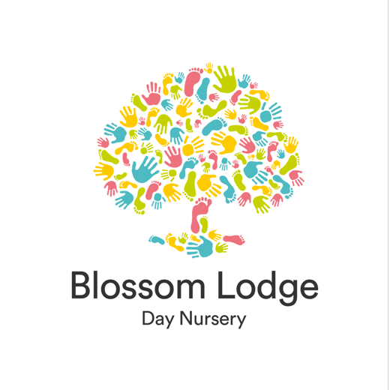




Nursery Fees

May 2026 - March 2027



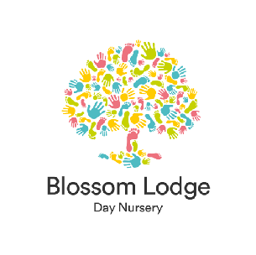
Nursery Fees

May 2026 - March 2027

Breakfast Club 7.30 – 8.00 am £6.25 Morning session 8.00am – 1pm £52.20
Extended morning session 8.00am – 2pm £65.92 Afternoon session 1.00pm – 6.00pm £52.20
Extended afternoon session 12.00pm – 6.00pm £65.92 All day session 8.00am – 6.00pm £94
All day for full timers 8.00am – 6.00pm (Mon-Fri)
£84.60 / £470
Supper Club 6.00pm – 6.30pm £6.25
Fee within Government funded hours £0.00

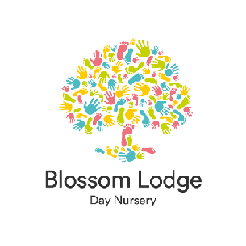
Nursery Fees
May 2026 - March 2027

Voluntary Consumables - only during funded childcare hours

0-2 years
Meals and snacks £6.75 per AM / PM
Consumables (nappies, wipes etc.) £3.25 per AM / PM
Activities and extras £5.00 per AM / PM

2-5 years
Meals and snacks £6.75 per AM / PM
Consumables (nappies, wipes etc.) £3.25 per AM / PM
Consumable for toilet trained children £1.25 per AM / PM
Activities and extras £5.00 per AM / PM

Funding policy and opt out consumable policies available at request.

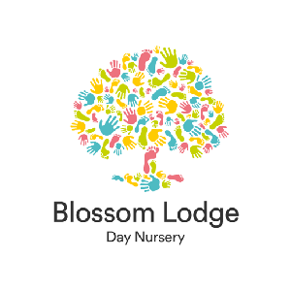
Nursery Fees
May 2026 - March 2027

Discounts
Blossom Lodge Day Nursery offers a 10% discount for siblings and NHS workers, please see below the terms and conditions:

A 10% discount will be applied to fees for NHS workers on all sessions apart from a full-time booking. Once a child is on Government funded hours this discount will only apply to non-funded hours

A 10% sibling discount will be applied to the youngest child’s fees until either child is using Government funded hours, this discount will then only apply to non-funded hours

Only one discount can be used, NHS and sibling discount if applicable will not be applied together,
NHS or sibling discount cannot be applied to full time week.

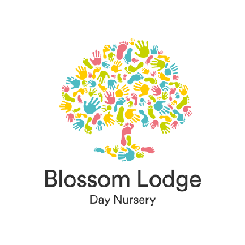
Nursery Fees
May 2026 - March 2027

Terms and Conditions

A non-refundable administration charge of £75 is required to secure your child’s place.
There is a minimum of 2 sessions per week The nursery is open for 51 weeks, full fees apply on bank holidays and days of absence/holidays.
Nursery fees are payable by the 1st of the month in advance
If the nursery closes due to unforeseen circumstances or events full fees apply, such as adverse weather
Parents of babies are required to provide all baby milk until your child is on Cow’s milk, please refer to our Milk Feed Policy

